Cloud Foundry Exercise

Purpose
In this exercise we demonstrate that we can also upload our local DHBW Home Page into the Cloud. For that we will use Juergen's IBM Bluemix Account and in in that account we will request a CloudFoundry Pivotal PaaS Service in order to host our Node.JS App. Being successful there we could now use our uploaded portal fron any browser in the world connected to the internet

Prerequisite
We need two new files in order to describe our deployment. One is the manifest.yml in order to describe the capacities and the build pack needed.
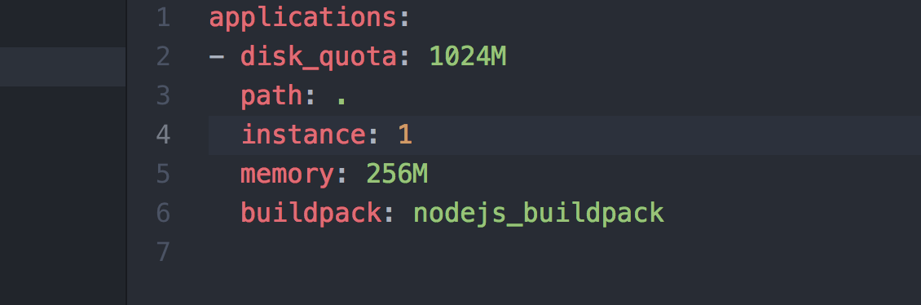
This manifest.yml defines the disk limit, the number of node.js instances, the memory usage and it specifies the the CloudFoundry build pack we can use for Node.JS. It is also possible to specify all those options with the actual CF push command.
The second important file is the package.json which defines all the dependencies to the additional packages we have for our Node.JS.
All the Node.JS package will bee loaded and bound to the deployment as part of the CF push command.

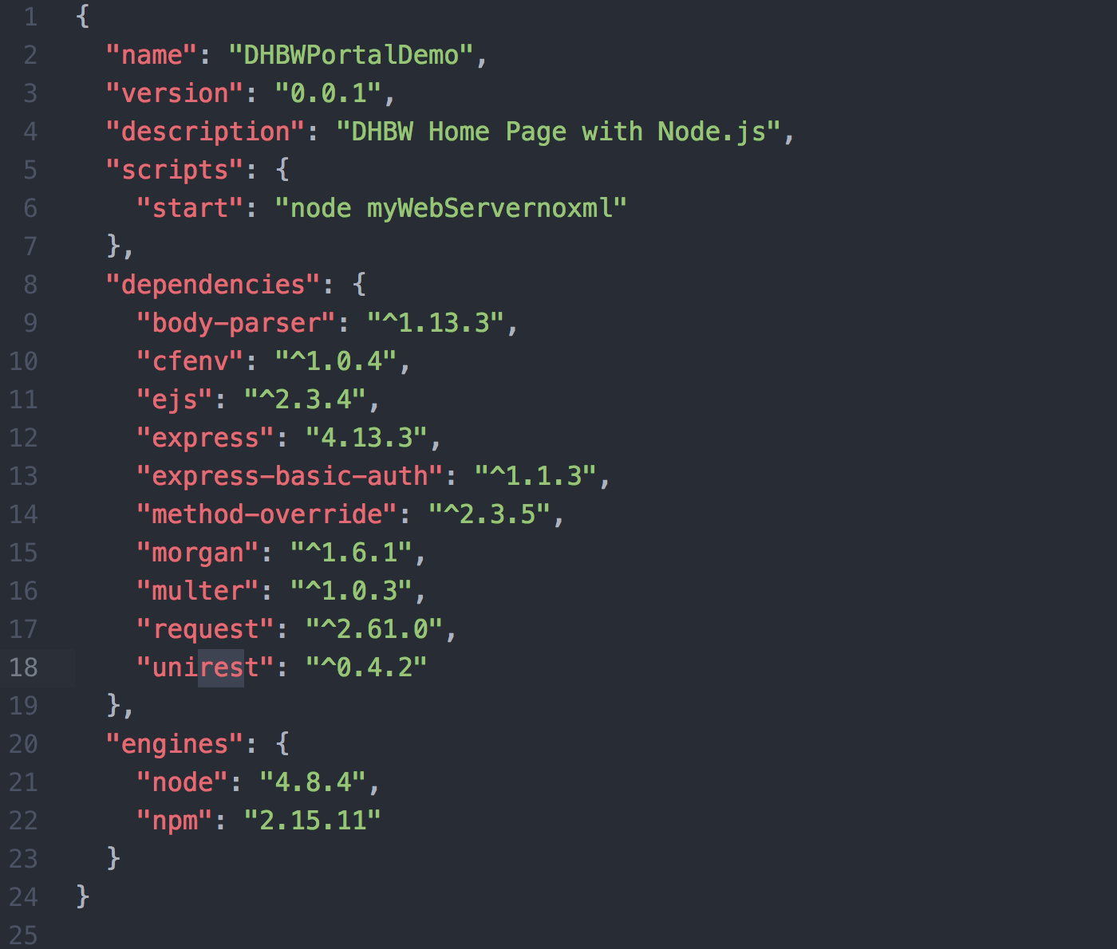
The dependencies section is build when we install all the node.js packages using the
- NPM Install –save
command.

We also added a start command to start our node server mywebservernoxml.js. While typically those packages don't have a dependency to a OS level function, the LIBXML.JS does. This is why we just removed that function from our original myWebServer.js.

Quick Demo on IBM Bluemix

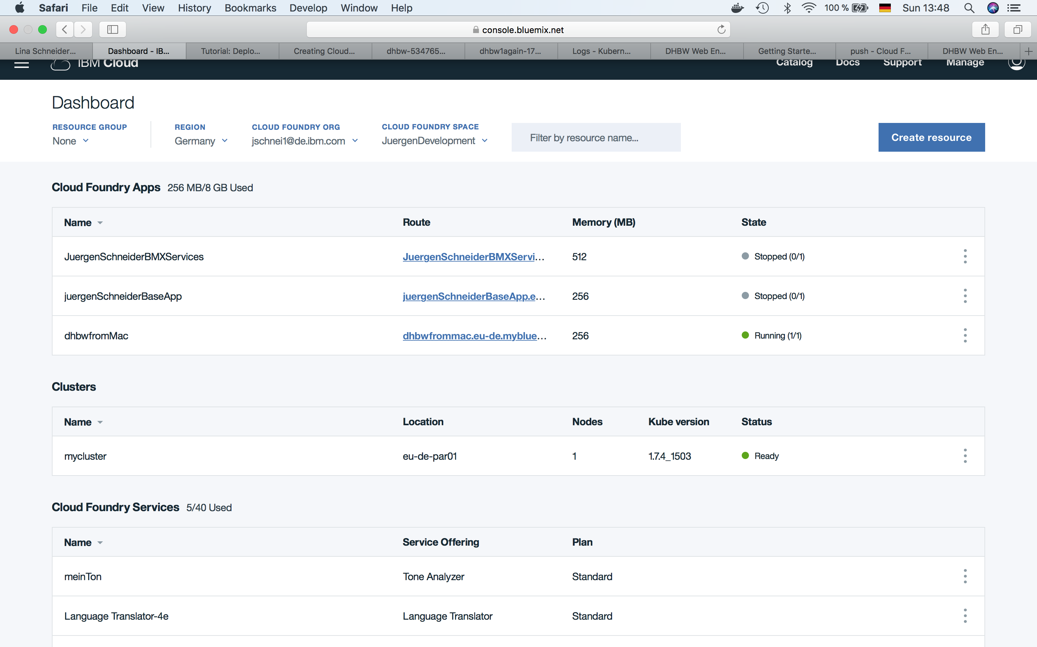

Upload the Deployment
Let us open a terminal session.
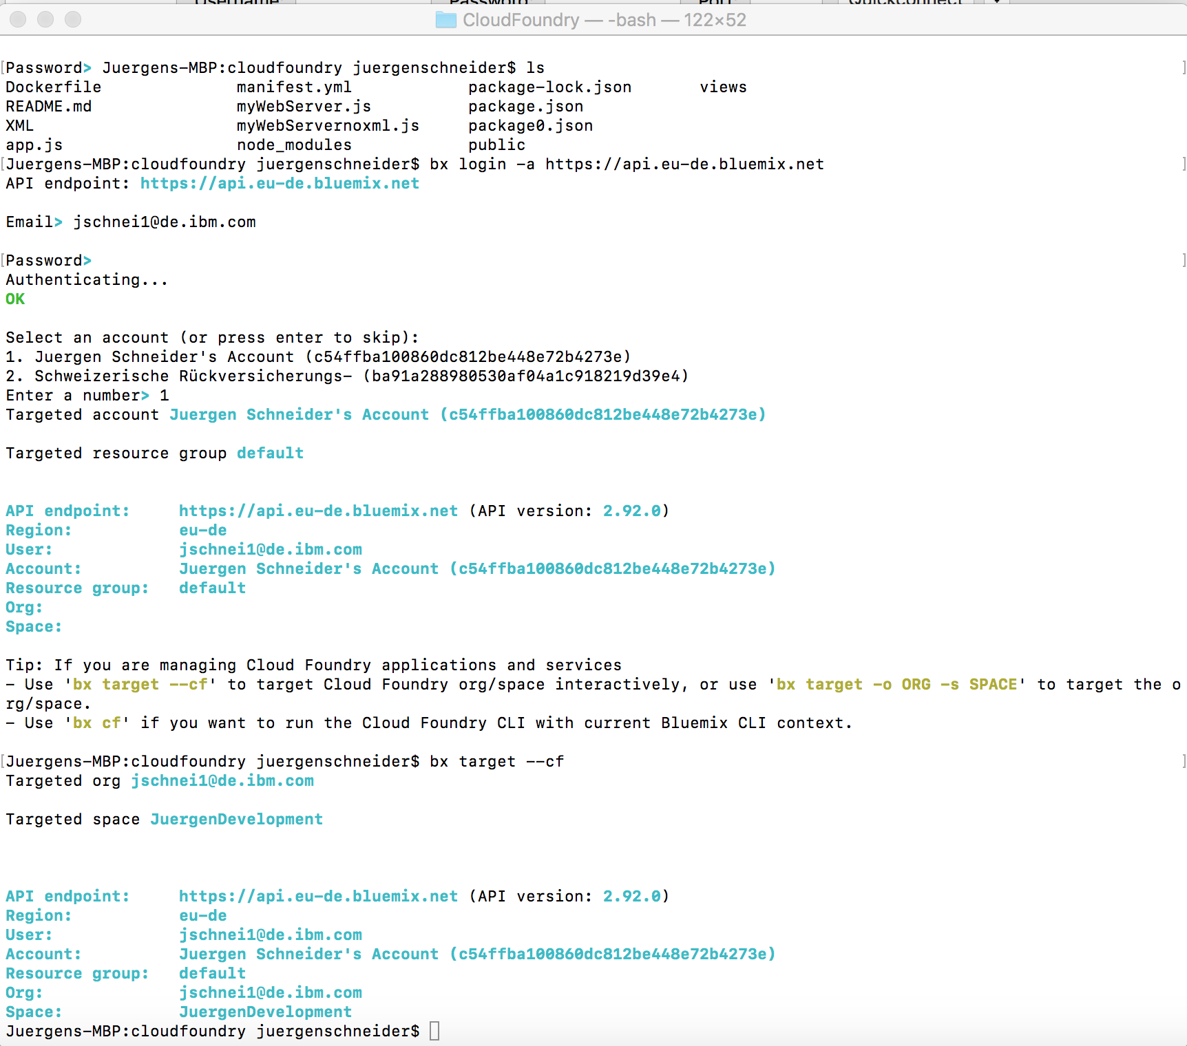
Now we are ready to enter the BX CF push command to push our implementation into the cloud.
- bx cf push "dhbwportal2" .. we name our deployment dhbwportal2 and all other parameter are taken from the manifest.yml. dhbwportal2 will also become the subdomain of our new url. dhbwportal2.eu-de.mybluemix.net
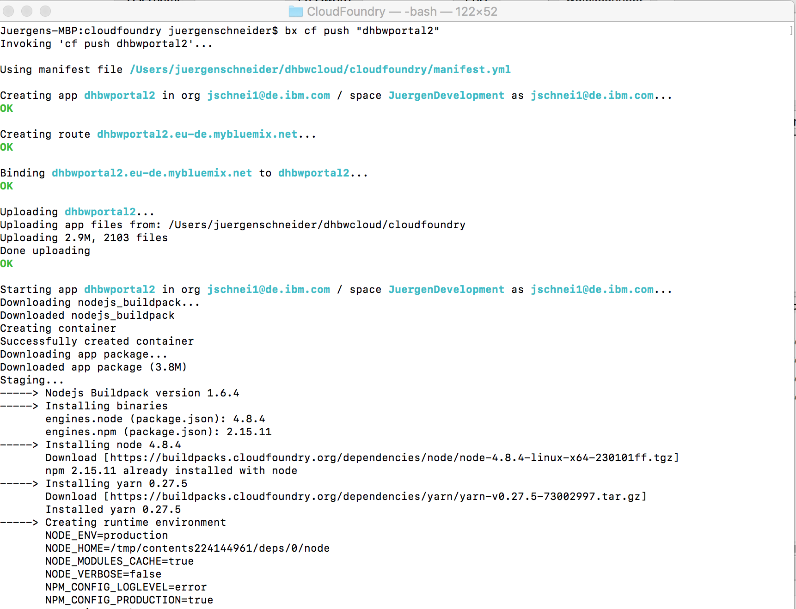
and more on the build process log. It finally ends like this:
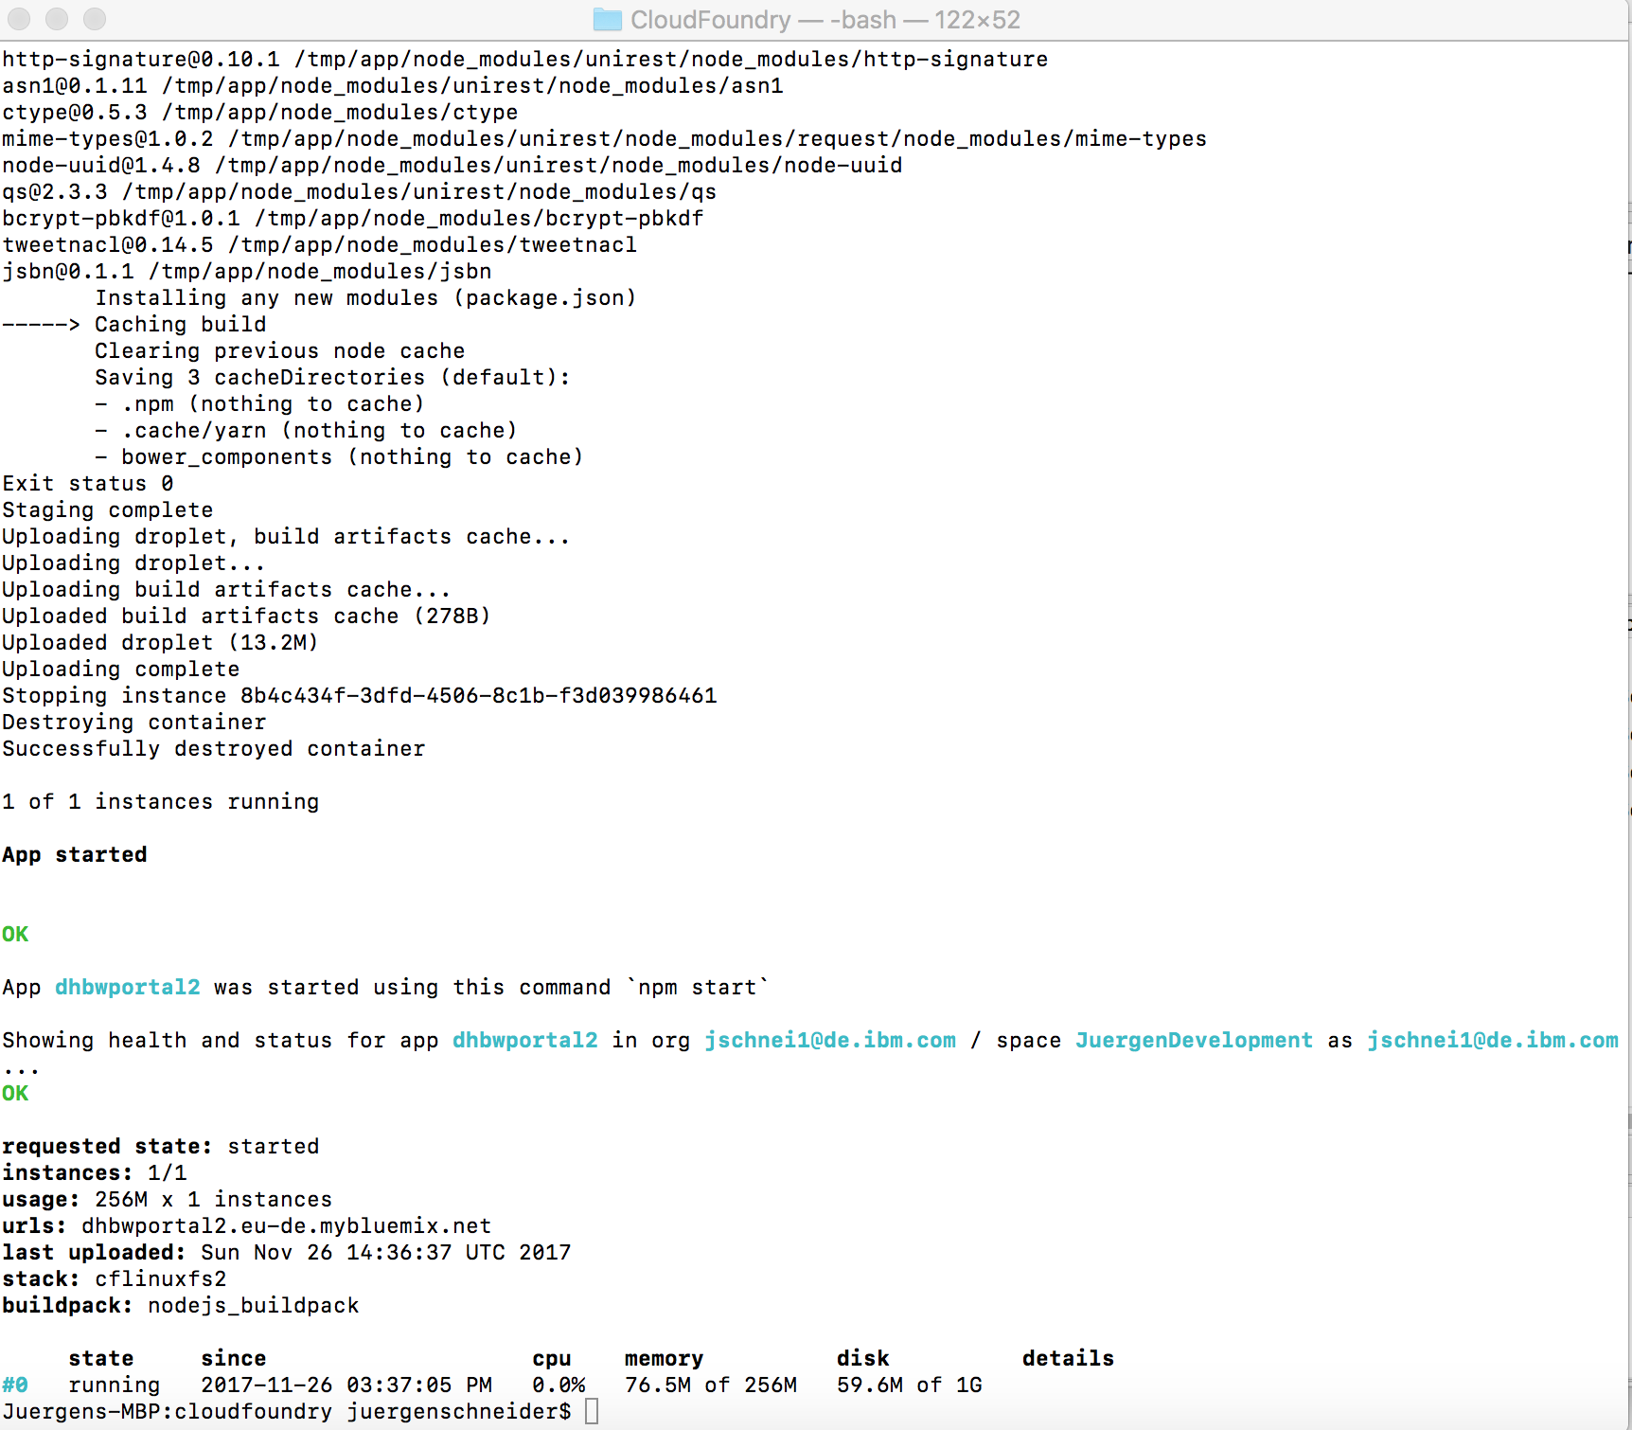
We are done....
now we can go back to the Bluemix dashboard and see the active deployment, or just enter the url into the browser:
- dhbwportal2.eu-de.mybluemix.net/static/mypage4.htm.

